Vaderland  
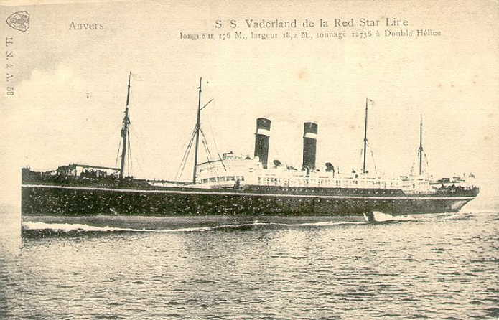

|  |  |  |  |  |  |  |  |  |  |  |  |  |  |  |  |  |  |  |  |  |  |  |  |  |
| --- | --- | --- | --- | --- | --- | --- | --- | --- | --- | --- | --- | --- | --- | --- | --- | --- | --- | --- | --- | --- | --- | --- | --- | --- |
| |  |  | | --- | --- | |  |  | |  |  |   Ship Information   |  |  |  |  |  |  |  |  |  |  |  |  |  |  |  |  |  |  |  | | --- | --- | --- | --- | --- | --- | --- | --- | --- | --- | --- | --- | --- | --- | --- | --- | --- | --- | --- | | |  |  | | --- | --- | | Ship Name: | Vaderland | | Years in service: | 1900-1915 | | Funnels: | 2 | | Masts: | 4 | | Aliases: | Southland (1915) | | Shipping Line: | Red Star | | Ship Description: | Built by John Brown & Co., Clydebank, Glasgow, Scotland. Tonnage: 11,899. Dimensions: 560' x 60' (580' o.l.). Twin-screw, 15 knots. Quadruple expansion engines. Four masts and two funnels. | | History: | Launched, July 12, 1900. Service: Antwerp-New York. Passengers: 340 first, 200 second, 600 third. Renamed: Southland (1915) British. Converted to troopship. Torpedoed and sunk 140 miles from Tory Island, June 4, 1917, with the loss of 4 lives. Sister ships: Finland, Kroonland and Zeeland. | |  |  | | |  |

