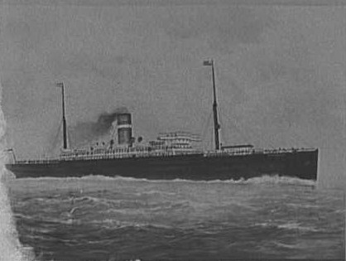

Ship Information

|  |  |  |  |  |  |  |  |  |  |  |  |  |  |  |  |  |
| --- | --- | --- | --- | --- | --- | --- | --- | --- | --- | --- | --- | --- | --- | --- | --- | --- |
| |  |  | | --- | --- | | Ship Name: | Statendam | | Years in service: | 1898-1911 | | Funnels: | 1 | | Masts: | 2 | | Aliases: | Scotian (1911), Marglen (1922) | | Shipping line: | Holland-America | | Ship description: | Built by Harland & Wolff, Ltd., Belfast, Ireland. Tonnage: 10,491. Dimensions: 515' x 59' (530' o.l.). Twin-screw, 15 knots. Triple expansion engines. Two masts and one funnel. | | History: | Commenced her maiden voyage from Rotterdam to New York in August 1898. Renamed: (a) Scotian (1911), (b) Marglen (1922). Scrapped in Italy, 1927. | |