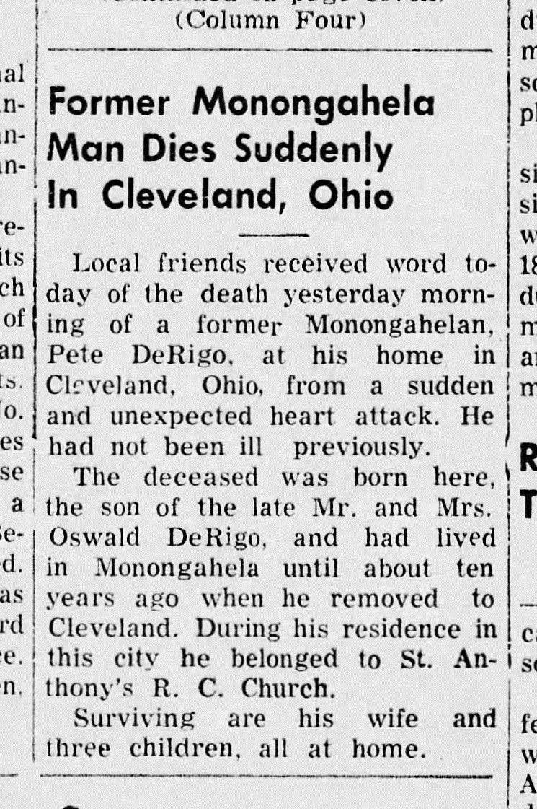
Peter A. DeRigo Obituary
The Daily Republican (Monongahela, PA)
23 Dec 1950
Page 1, Column 2

