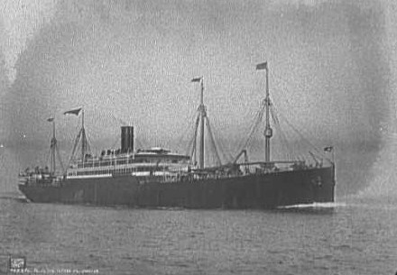

Ship Information

|  |  |  |  |  |  |  |  |  |  |  |  |  |  |  |  |  |  |  |
| --- | --- | --- | --- | --- | --- | --- | --- | --- | --- | --- | --- | --- | --- | --- | --- | --- | --- | --- |
| |  |  | | --- | --- | | Ship Name: | Pennsylvania | | Years in service: | 1896-1917 | | Funnels: | 1 | | Masts: | 4 | | Aliases: | Nansemond (1917) | | Shipping line: | Hamburg-American | | Ship description: | Built by Harland & Wolff, Ltd., Belfast, Ireland. Tonnage: 13,333. Dimensions: 559' x 62'. Twin-screw, 13 1/2 knots. Quadruple expansion engines. Four masts and one funnel. | | History: | Passengers: 160 first, 180 second, 2,200 third. Service: Hamburg-New York. Renamed: Nansemond (1917) United States troopship. Scrapped in 1924. Sister ships: Graf Waldersee, Patricia and Pretoria. Note: Large passenger-cargo type steamships, which could carry more cargo on one voyage than the entire Hamburg-American Line sailing fleet of the 1850's in a whole year. | |  |  | |