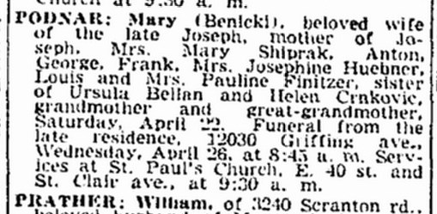
Obituary of Mary Benicki Podnar, sister of Ursula Benicki Bellan
The Cleveland Plain Dealer
24 Apr 1944
Page 15, Column 2

