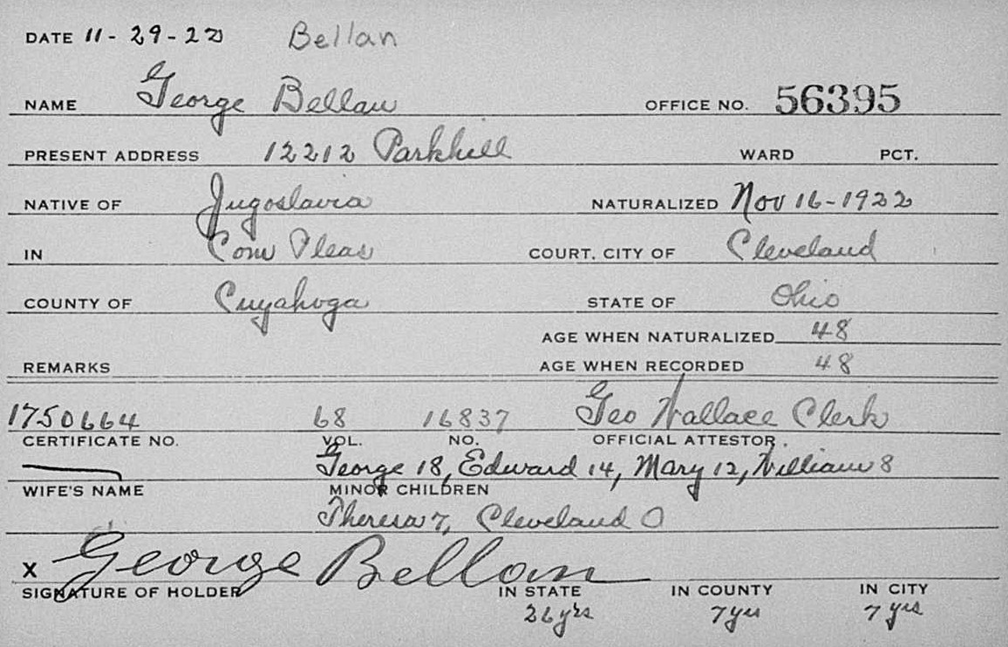

George Bellan, "Ohio, County Naturalization Records, 1800-1977"
name: | George Bellan
event: | Naturalization
event year: | 1922
event place: | Cleveland, Cuyahoga, Ohio, United States
age: | 48
birth year:
estimated birth year: | 1874
birthplace: | Yugoslavia
film number: | 2372103
digital folder number: | 005486591
image number: | 03500

Citing this Record
"Ohio, County Naturalization Records, 1800-1977," index and images, FamilySearch (https://familysearch.org/pal:/MM9.1.1/K8H3-RRN : accessed 31 Dec 2012), George Bellan, 1922.

