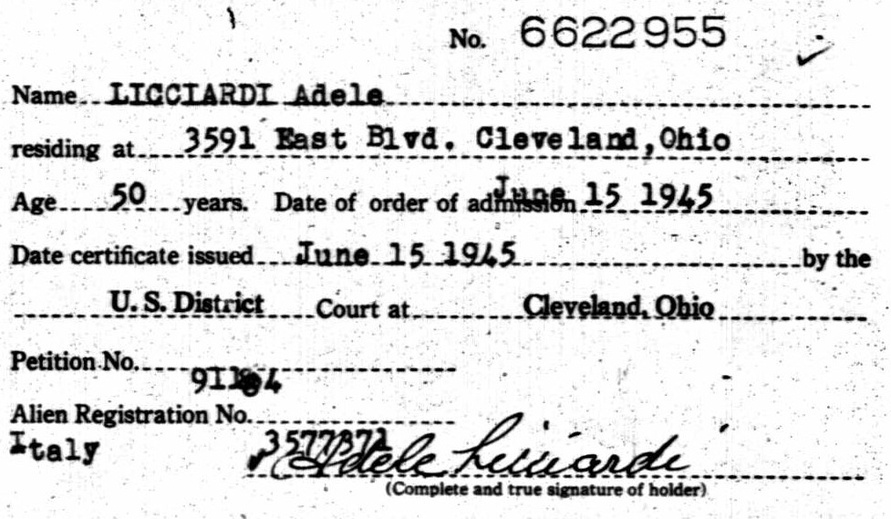
U.S. Naturalization Records Indexes, 1794-1995
Name: Adele Licciardi
Age: 50
Birth Date: abt 1895
Issue Date: 15 Jun 1945
State: Ohio
Locality, Court: Cleveland, District Court
Source Citation: National Archives and Records Administration (NARA); Washington, D.C.; Index Cards to Naturalization Petitions for the U.S. District Court for the Northern District of Ohio, Eastern Division, Cleveland, 1855-1967; Microfilm Serial: M1893; Microfilm Roll: 17.
Source Information:
Ancestry.com. U.S. Naturalization Records Indexes, 1794-1995 [database on-line]. Provo, UT, USA: Ancestry.com Operations, Inc., 2007.
Original data: National Archives and Records Administration (NARA) Microfilm Publications; Records of District Courts of the United States, Record Group 21; National Archives, Washington, D.C. Scroll down to the bottom of this page for
Description:
This database contains indexes to U.S. naturalization records (primarily Declarations and Petitions) for various courts (primarily U.S. District and Circuit courts) and years. Indexes are lists of names, with the associated volume and page number, compiled from the records by the court where the file was located.

