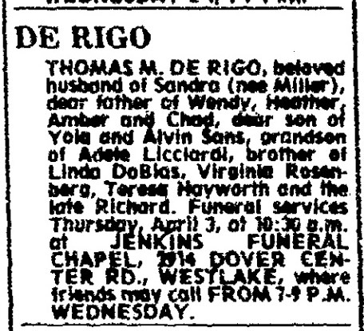
Obituary of Thomas Derigo, son of Yola Licciardi DeRigo Sans
Cleveland Plain Dealer
2 Apr 1980
Page 79, Column 2

