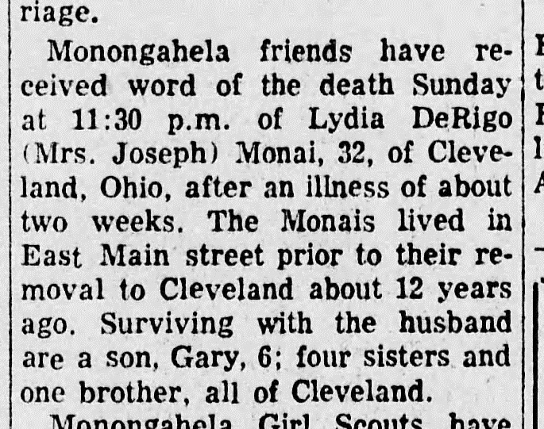
Lydia DeRigo Monai Obituary
The Daily Republican (Monongahela, PA)
8 Mar 1949
Page 6, Column 6

