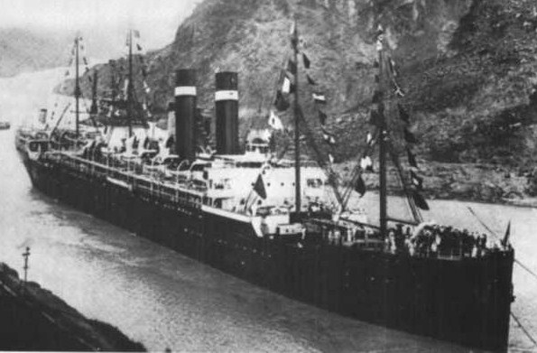

Ship Information

|  |  |  |  |  |  |  |  |  |  |  |  |  |  |  |
| --- | --- | --- | --- | --- | --- | --- | --- | --- | --- | --- | --- | --- | --- | --- |
| |  |  | | --- | --- | | Ship Name: | Finland | | Years in service: | 1902-1927 | | Funnels: | 2 | | Masts: | 4 | | Shipping line: | Red Star | | Ship description: | Built by Wm. Cramp & Sons, Shipbuilding & Engineering Co., Philadelphia, Pa. Tonnage: 12,188. Dimensions: 560' x 60' (580' o.l.). Twin-screw, 16 knots. Triple expansion engines. Four masts and two funnels. | | History: | Service: Antwerp-New York. Also served in American Line service. Transferred to Panama-Pacific Line late in 1923. Scrapped in 1927. Sister ships: Kroonland, Vaderland and Zeeland. | |