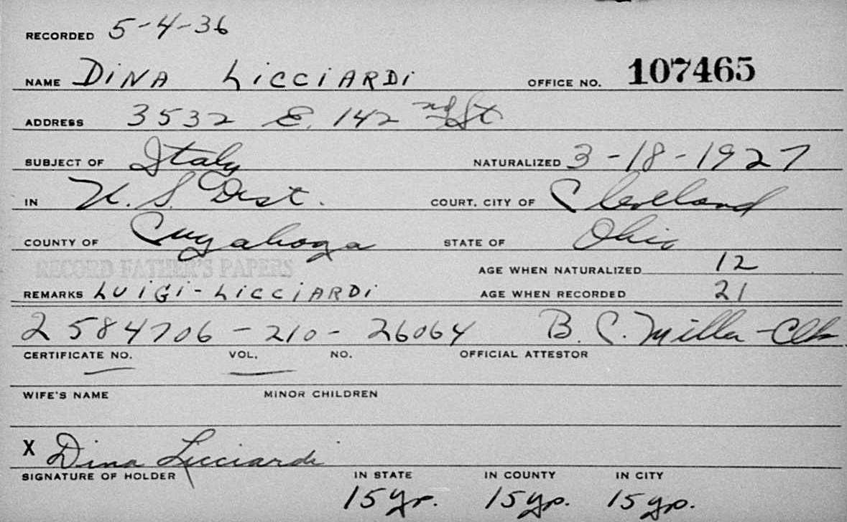
name: | Dina Licciardi
event: | Naturalization
event year: | 1927
event place: | Cleveland, Cuyahoga, Ohio, United States
age: | 12
birth year:
estimated birth year: | 1915
birthplace: | Italy
film number: | 2251756
digital folder number: | 005486577
image number: | 04793

Citing this Record
"Ohio, County Naturalization Records, 1800-1977," index and images, FamilySearch (https://familysearch.org/pal:/MM9.1.1/K8HS-M4X : accessed 29 Jan 2013), Dina Licciardi, 1927.

